**BUILDING A DIGITAL COMMUNITY PLATFORM: A WEB-BASED APPLICATION FOR HILLSVIEW HOMES**

**WITH INTERACTIVE FORUM**

A Capstone Project presented to the Faculty of the

College of Information Technology and Computer Studies

Pamantasan ng Lungsod ng Muntinlupa

Muntinlupa City

In Partial Fulfillment Of the Requirements for the Degree of

Bachelor of Science in Information Technology

**ANCAJAS, JOHN ANDREI M.**

**ESTUISTA, ALLEONA M.**

**RILI, MARVIN C.**

**MARCH 2025**

**APPROVAL SHEET**

This is to certify that this capstone project, entitled: **BUILDING A DIGITAL COMMUNITY PLATFORM: A WEB-BASED APPLICATION FOR HILLSVIEW HOMES WITH INTERACTIVE FORUM** and submitted by **ANCAJAS JOHN ANDREI, ESTUISTA ALLEONA** AND **RILI MARVIN** to fulfill part of the requirements for the degree of BACHELOR OF SCIENCE IN INFORMATION TECHNOLOGY, is hereby endorsed.

**______________________** **KAYCEE R. MENDEZ, MIT, LPT**

Language EditorAdviser

Approved and accepted in partial fulfillment of the requirement for the degree

of BACHELOR OF SCIENCE IN INFORMATION TECHNOLOGY, by the Oral Examination Committee.

**CLARK ADRIAN T. WICK, MIT IVAN CARL R. CAPUNITAN, MIT** Member Member

**MELCHOR L. PAZ, MSCS**

Committee Chair

The College of Information Technology and Computer Studies accepted this capstone project in partial fulfillment of the requirements for the degree of BACHELOR OF SCIENCE IN INFORMATION TECHNOLOGY.

**KAYCEE R. MENDEZ, MIT, LPT**

Information Technology Program Chair

**ALAIN J. ANUEVO, MIT**

Dean, CITCS

**BUILDING A DIGITAL COMMUNITY PLATFORM: A WEB-BASED APPLICATION FOR HILLSVIEW HOMES WITH INTERACTIVE FORUM**

Ancajas, John Andrei M. Estuista, Alleona M. Rili, Marvin C.

ancajasjohnandrei_bsit@plmun.edu.ph [estuistaalleona_bsit@plmun.edu.ph](mailto:estuistaalleona_bsit@plmun.edu.ph) rilimarvin_bsit@plmun.edu.ph

**EXECUTIVE SUMMARY**

The Hillsview Digital Platform is a web-based application designed for Hillsview Homes, a residential community in Putatan, Muntinlupa. The researchers aim to develop an automated community management system that enhances communication, service accessibility, and security within the community. The system will enable real-time announcements, streamlined service requests, incident reporting, and secure financial transactions, ensuring an organized and efficient residential experience. The primary beneficiaries of the system are the residents of Hillsview Homes, while the main users include homeowners, the Homeowners Association (HOA), security personnel, and local service providers. The researchers utilized the Rapid Application Development (RAD) methodology, which is suitable for this project due to its iterative approach, allowing for faster prototyping, feedback integration, and efficient system deployment.

The researchers thoroughly analyzed and evaluated the system’s effectiveness through rigorous software testing, including Alpha and Beta testing, based on user feedback. The evaluation phase yielded excellent results, demonstrating the platform’s usability, efficiency, and reliability.

The study concludes that the Hillsview Digital Platform is an effective unified system for residential management in Hillsview Homes. The researchers recommend expanding the platform by integrating advanced security features, additional service provider tools, and further optimizations to enhance community engagement and ensure sustained technological adoption.

***Keywords:*** community management, digital platform, service requests, incident reporting, secure transactions, online communication

**ACKNOWLEDGMENT**

The researchers would like to express their deepest gratitude to everyone who contributed to the successful completion of this capstone project, **"Hillsview Digital Platform: A Web-Based Community Management System for Hillsview Homes."**

First and foremost, we give our highest praise and gratitude to the **Almighty God** for His guidance, wisdom, and strength throughout this journey. His grace has been our source of resilience and determination, allowing us to overcome challenges and accomplish this project.

We extend our sincerest appreciation to our **families**, who have been our unwavering support system. Their patience, encouragement, and financial assistance have made this endeavor possible. Without their love and sacrifices, we would not have been able to dedicate ourselves fully to this project.

A heartfelt thank you to our **capstone adviser,** **Kaycee R. Mendez,** for her invaluable guidance, insights, and encouragement. Her expertise has been instrumental in shaping the direction and quality of our research.

We are also deeply grateful to the **residents of Hillsview Homes**, who willingly participated in our surveys and provided valuable feedback. Their cooperation and input were crucial in ensuring that the system we developed aligns with the needs of the community.

This project would not have been possible without the collective effort and support of all those mentioned. From the bottom of our hearts, **thank you!**

**DEDICATION**

This capstone project is **wholeheartedly dedicated** to the people who have been our pillars of strength and inspiration throughout this journey.

To our **Almighty God**, who has blessed us with wisdom, patience, and perseverance, guiding us through every challenge we encountered. His grace has been our foundation, and without Him, this achievement would not have been possible.

To our **beloved families**, whose unwavering support, encouragement, and sacrifices have made this endeavor a reality. Their patience, love, and financial assistance have given us the strength to push forward, even in the most challenging times.

To our **friends and peers**, who have provided us with valuable insights, constructive feedback, and endless motivation. Their willingness to share ideas and lend a helping hand has contributed immensely to the success of this project.

To the **residents of Hillsview Homes**, whose cooperation and participation in our study have been instrumental in shaping the development of our system. Their trust and support have given meaning and purpose to our work.

Lastly, we dedicate this project to **all aspiring innovators and researchers**, hoping that this work serves as an inspiration to continue seeking knowledge, developing solutions, and making meaningful contributions to society.

This is for all of you. **Thank you!**

**TABLE OF CONTENTS**

Page

Title Page…………………………………………………………….….i

Approval Sheet…………………………………………………………ii

Executive Summary…………………………………………………....iii

Acknowledgment …………………………………………………...... iv

Dedication ……………………………………………………………...v

Table of Contents………………………………………………….…...vi

List of Tables ………………………………………………………..…ix

List of Figures…………………………………………………………..x

**CHAPTER 1. INTRODUCTION**

Project Context ………………………………………………….1

Purpose and Description ………...……………………………....2

Objectives of the Study………………………………………….4

Scope and Limitations.……………………………….………….4

**CHAPTER 2. REVIEW OF RELATED LITERATURE AND STUDIES**

Technical Background…………………………………………...6

Related Studies.………………………………………………….6

**CHAPTER 3. METHODOLOGY**

Requirement Analysis……………………….…………………..12

Requirement Documentation………………………….……....…14

Design of Software, System, Product or Process ….……………18

Development and Testing …………………………….…………22

Implementation Plan……………………………………..............24

**CHAPTER 4. RESULT AND DISCUSSION**

Project Description …………………………..….………………….26

Project Structure ………………………………………....................26

Project Capabilities and Limitation ……………...…………………29

Project Evaluation …………………………………………………32

**CHAPTER 5. CONCLUSION AND RECOMMENDATION**

Summary of Findings………………………………………………..

Conclusion …………………………………………..……………..35

Recommendations……………………………………………………36

**REFERENCES**

[1] K. E. Kendall and J. E. Kendall, Systems Analysis and Design: An Object- Oriented Approach with UML. Upper Saddle River, NJ, USA: Pearson, 2014.

[2] J. W. Satzinger, R. B. Jackson, and S. D. Burd, Systems Analysis and Design in a Changing World. Boston, MA, USA: Cengage Learning, 2015.

[3] R. S. Pressman, Software Engineering: A Practitioner's Approach. New York, NY, USA: McGraw-Hill, 2014.

[4] S. W. Ambler, "Introduction to UML 2 Sequence Diagrams," Agile Modeling, 2004.

[5] D. Rosenberg and K. Scott, Use Case Driven Object Modeling with UML: A Practical Approach. Boston, MA, USA: Addison-Wesley, 2001.

[6] A. Adesipo, "Smart Community Security and Privacy: A Sensor-Based Approach," Sensors, vol. 20, no. 4, pp. 1-20, 2020.

[7] S. Kim, "Smart City Implementation: A Case Study of Seoul," Urban Studies, vol. 53, no. 5, pp. 1-20, 2016.

[8] K. Polyzois, "Enhancing Indigenous Community Participation in Community Planning Through Online Tools," Journal of Community Informatics, vol. 14, no. 1, pp. 1-20, 2018.

[9] R. J. Moore and M. Carter, "Designing Engaging Digital Communities: A Framework for Managed Community Experiences."

[10] M. Conti, J. Li, and S. Ahmed, "Security and Privacy in Smart Communities: Challenges and Opportunities."

[11] S. J. Lee and T. M. Hale, "Building a Smart Community Through the Integration of Technology, Social Capital, and Collective Efficacy."

[12] M. A. Badamas and H. M. Hasan, "The Role of Digital Technologies in Enhancing Community Engagement and Participation."

[13] J. Pluto-Kossakowska, "Use of Dashboards in City Planning: A Review of Current Practices and Future Directions," Sustainability, vol. 14, no. 17, 2022.

[14] M. I. Khan, M. Waqas, and G. Muhiuddin, "A Comprehensive Review of Online Bill Payment Systems: Models, Technologies, and Trends."

[15] Y.-t. Lee, W.-h. Hsiao, C.-m. Huang, and S.-c. T. Chou, "An Integrated Cloud-Based Smart Home Management System with Community Hierarchy," IEEE Transactions on Consumer Electronics, vol. 62, no. 1, pp. 1-9, Feb. 2016.

**APPENDICES**

1. Relevant Source Code
2. Evaluation Tool Sample

* Sample Evaluation Instrument (for IT Experts)

1. Sample Input/Output/Reports

* Letter to Conduct Study
* Letter of Acceptance
* Certificate of Originality

1. User’s Guide
2. Request Letters

* Adviser
* Defense Panel
* Language Editor
* Endorsement for Title Presentation
* Endorsement for Oral Presentation
* Endorsement for Book Compilation

1. Pictures showcasing the data gathering, investigation done
2. Curriculum Vitae

**LIST OF TABLES**

**Table No. Page**

1. Testing Result (President)………..………………………….……….31
2. Testing Result (Vice President)…………………………….………..31
3. Testing Result (Secretary)………………………………….………..32
4. Testing Result (Admin)…………………………………….………..32
5. Summary of the Mean Score of the

Evaluation Report from IT Experts….…………………………..…..33

**LIST OF FIGURES**

Figure No. Page

1. Existing System (Messenger)…………………………………………….13

2. Functional Decomposition Diagram……………………………………...15

3. Use Case Diagram of the Proposed System………………………………16

4. Entity-Relationship Diagram of the Proposed System……………………17

5. Data Flow Diagram (DFD) Level 0………………………………………18

6**.** Data Flow Diagram (DFD) Level 1………………………………………19

7. Conceptual Framework…………………………………………………...20

**CHAPTER 1**

**INTRODUCTION**

**PROJECT CONTEXT**

Hillsview Homes, a small community nestled in Putatan, Muntinlupa, struggles with fundamental challenges that hinder its residents’ quality of life. Key issues in communication, convenience, and security disrupt day-to-day living and limit the potential for cohesive community development. A major concern is the lack of effective communication channels within the community. Residents often face difficulties in accessing accurate and timely information regarding announcements, events, or emergencies. This communication gap creates confusion, isolates individuals, and undermines the ability to foster strong social ties and collective action among residents.

Equally problematic is the inconvenience associated with accessing essential services and resources. From locating service providers to organizing logistics for basic necessities, residents are forced to navigate an inefficient and fragmented system. These challenges not only consume valuable time but also diminish the overall convenience of living within Hillsview Homes.

Security also poses a significant issue for the community. The absence of a centralized system for reporting safety concerns or addressing incidents create vulnerabilities for residents. Without reliable tools for sharing security updates or seeking assistance during emergencies, the sense of safety within the community remains compromised.

These interconnected challenges highlight the need for unified and innovative approach to addressing communication, convenience, and security in Hillsview Homes. By tackling these issues, the community can move toward a more connected, accessible, and secure living environment.

**PURPOSE AND DESCRIPTION**

The importance of our study lies in its potential to significantly enhance the

Quality of life and overall well-being of residents within Hillsview Homes. By addressing the challenges of communication, security, and data management through the development of a comprehensive Laravel application, our research serves several crucial purposes:

1. **Improving Community Dynamic:** Effective communication is the lifeblood of any community. By streamlining communication channels, our study aims to foster better relationships among residents and management, promoting a stronger sense of community cohesion and unity within Hillsview Homes. This improvement in community dynamics can lead to increased resident satisfaction and a more vibrant community atmosphere.
2. **Enhancing Safety and Security:** Security is paramount for residents' peace of mind. Through the integration of advanced security measures into the Laravel application, such as surveillance systems and access controls, our study aims to create a safer living environment for residents.

This enhancement in safety measures not only protects residents from potential threats but also contributes to a sense of security and well-being within the community.

1. **Optimizing Administrative Processes:** Efficient data management is essential for smooth administrative operations. By providing tools for better organization and management of resident data, our study aims to streamline administrative processes within Hillsview Homes. This optimization can lead to improved decision-making, resource allocation, and overall operational efficiency, benefiting both residents and management alike.
2. **Promoting Technological Advancement:** Embracing technology is key to staying relevant and competitive in today's digital age. By introducing a Laravel application tailored specifically for Hillsview Homes, our study promotes the adoption of innovative solutions to address real-world challenges. This digital platform integrates several essential features to enhance community living and is exclusively accessible to signed-in residents of Hillsview, ensuring privacy and exclusivity for the community.
3. **Optimizing Administrative Processes:** Efficient data management is essential for smooth administrative operations. By providing tools for better organization and management of resident data, our study aims to streamline administrative processes within Hillsview Homes. This optimization can lead to improved decision-making, resource allocation, and overall operational efficiency, benefiting both residents and management alike.
4. **Promoting Technological Advancement:** Embracing technology is key to staying relevant and competitive in today's digital age. By introducing a Laravel application tailored specifically for Hillsview Homes, our study promotes the adoption of innovative solutions to address real-world challenges. This digital platform integrates several essential features to enhance community living and is exclusively accessible to signed-in residents of Hillsview, ensuring privacy and exclusivity for the community.

The primary function of the Hillsview Homes system is to serve as a centralized

digital platform for seamless communication, efficient service management, and community-wide connectivity. This Laravel-powered application facilitates real-time information sharing, allowing residents and management to exchange updates, announcements, and important notices instantly. It also simplifies the handling of service requests through FixHub, an exclusive feature that enables signed-in residents to efficiently community.

***Below are the beneficiaries who will benefit the system:***

•**Residents of Hillsview Homes** - Residents gain access to a cutting-edge platform that significantly enhances their daily lives.

•**HOA (Home Owners Association) of Hillsview Homes** - The platform empowers community management to streamline operations and foster resident satisfaction.

•**Local Businesses and Service Providers -** The system also fosters

economic opportunities within the community by integrating local businesses and service providers into its ecosystem

**OBJECTIVE OF THE STUDY**

***General Objective***

The general objective of our study is to develop and implement a comprehensive Laravel application system tailored specifically for Hillsview Homes, aimed at enhancing communication, convenience, security, and data management within the community. Through this endeavor, we aim to improve the overall quality of life for residents, streamline administrative processes for management, and foster stronger community cohesion and well-being.

***Specific Objectives***

1. To design a system using the following features:
2. To analyze the current challenges in communication, security, and service accessibility within Hillsview Homes.
3. To design a user-friendly and secure digital platform that addresses the identified challenges.
4. To implement a system that improves community engagement and streamlines administrative operations.
5. To evaluate the effectiveness and usability of the developed system through comprehensive testing and feedback collection.
6. To ensure that the system complies with best practices in software engineering and community management.
7. To develop the system using the programming languages and framework:
8. Html/css
9. Laravel
10. Sql
11. Php
12. Javascript
13. To test the system using testing tool.
14. To evaluate the system using the evaluation tool.

**SCOPE AND LIMITATION**

***Scope of The Study***

It's important to note that this system is specifically designed for the unique needs of Hillsview Homes and may not be directly transferable to other residential communities with differing requirements. Additionally, the application's optimal functionality is contingent upon a stable internet connection, which could present challenges in areas with inconsistent network coverage. While the current design addresses immediate objectives, future enhancements or advanced customizations may necessitate additional development phases. The success of the system will also heavily rely on user acceptance and engagement, factors that, while critical, fall outside the direct scope of this project. Despite rigorous testing protocols, unforeseen bugs or compatibility issues may emerge upon deployment in live environments. Financial transactions within the payment module will depend on third-party gateways, potentially affecting transaction processing times and introducing delays beyond the system's direct control. The system's effectiveness assumes active participation from residents, service

providers, and administrators. Although robust security measures are implemented, they may not fully mitigate risks associated with sophisticated cyberattacks beyond the anticipated scope. Resource constraints, including time and funding, have limited the integration of advanced features such as AI-based insights or enhanced predictive analytics. Furthermore, the system does not include dedicated mobile applications but relies on a responsive browser-based design to ensure compatibility across various devices. Training for administrators, service providers, and residents on system usage is beyond the project's scope and will require separate arrangements by Hillsview Homes. Customization of generated reports may be confined to predefined formats and criteria available in the current system version. Lastly, periodic system downtime for maintenance and updates is unavoidable to maintain system integrity and may temporarily disrupt access.​

***Limitation of the Study***

The system's performance is highly dependent on a stable internet connection, which could pose challenges in areas with inconsistent network coverage, potentially affecting real-time functionality. While the system effectively addresses Hillsview Homes' immediate needs, any future enhancements, additional features, or advanced customizations will require further development phases beyond the initial implementation.User acceptance and engagement will be crucial to the system’s overall success, yet these factors fall outside the scope of the project and cannot be directly controlled by the development team. Despite rigorous Alpha and Beta testing, the possibility of unforeseen software bugs or compatibility issues remains,

especially when deployed in a live environment where real-world usage scenarios may introduce unexpected challenges. The payment module within the system relies on third-party gateways, meaning transaction processing times and potential delays are beyond the system’s direct control.For the system to function optimally, active participation from residents, service providers, and administrators is essential. While security features are built with industry best practices, they may not fully mitigate risks associated with sophisticated cyber threats, as no system is entirely immune to potential breaches. Due to constraints in time, resources, and funding, certain advanced capabilities, such as AI-driven insights and predictive analytics, have not been integrated into the current version.

The system is designed as a browser-based platform with responsive functionality across devices, eliminating the need for a dedicated mobile application. However, this reliance on a web-based interface may affect user experience compared to native mobile apps. Additionally, training for administrators, service providers, and residents on proper system usage is not included within the project’s scope and will require separate arrangements by Hillsview Homes management.Customization of generated reports is limited to predefined formats and filtering criteria, meaning users may have restrictions in tailoring reports to specific needs. System downtime for maintenance and updates is an unavoidable aspect of ensuring system integrity, and temporary disruptions may occur during such periods.

**CHAPTER 2**

**REVIEW OF THE RELATED LITERATURE AND STUDIES**

**TECHNICAL BACKGROUND**

The Hillsview Homes village portal is designed to create a cohesive and integrated digital platform that addresses the unique needs of a residential community. This portal aims to enhance communication, convenience, and security for the residents of Hillsview Homes. By leveraging advanced web development technologies and adhering to best practices in software engineering, this project will provide a robust, scalable, and user-friendly system.

**OVERVIEW OF TECHNOLOGY STACK**

***Laravel Framework***

Laravel is a highly popular PHP framework renowned for its elegant syntax and extensive feature set. It follows the Model-View-Controller (MVC) architectural pattern, which promotes the separation of concerns, thereby enhancing maintainability and scalability.

***Database Management***

MySQL, a reliable and efficient relational database management system, will be used to store and manage application data.

**RELATED STUDIES**

In the realm of system analysis and design, a solid foundation in established methodologies and best practices is pivotal for project success. This section delves into relevant literature that informs the key concepts and principles applied in the development of the Hillsview Portal. These sources offer valuable insights into systems analysis, design, and software engineering methodologies.

Kendall and Kendall [1] provide a comprehensive guide in their textbook, "Systems Analysis and Design: An Object-Oriented Approach with UML." This work serves as a cornerstone for structuring the analysis and design phases of the Hillsview Portal. By emphasizing object-oriented methodologies and the use of Unified Modeling Language (UML), it provided our team with a systematic approach for visualizing system components, interactions, and data flows.

This reference reinforced the importance of aligning system design with user requirements, a critical aspect of our project's agile approach. A changing technological and business landscape necessitates adaptability. Satzinger, Jackson, and Burd [2], in their book "Systems Analysis and Design in a Changing World," underline the significance of adapting to evolving environments. Their insights proved invaluable in our project's context, reminding us to consider the dynamic nature of technology and business as we crafted the Hillsview Portal.

Pressman [3], in "Software Engineering: A Practitioner's Approach," is a classic in the field of software engineering. This reference offers insights into the systematic development of software systems, a crucial aspect of system design. It has been instrumental in shaping our approach to software development, focusing on quality, reliability, and the importance of adhering to best practices.

Ambler [4] provides a resource for understanding UML 2 sequence diagrams, an important tool for visualizing event flows and interactions in system design. This online resource, "Introduction to UML 2 Sequence Diagrams," is particularly helpful for capturing and representing the flow of events in our project.

Rosenberg [5] explores the use case-driven approach to system modeling and design in "Use Case Driven Object Modeling with UML: A Practical Approach." This technique has been instrumental in capturing system requirements and functionalities effectively, aligning our project with user needs and expectations.

Adesipo [6], in their article "Smart Community Security and Privacy: A Sensor-Based Approach," published in Sensors in 2020, discusses the implementation of sensor-based technologies for enhancing community security and privacy. The insights from this work have been particularly useful in designing the advanced security features of the Hillsview Portal, including surveillance systems and access controls, ensuring a safer living environment for residents. This article also emphasizes the importance of smart agricultural techniques, which can inform broader smart village initiatives, highlighting the need for sustainable development frameworks.

Kim [7], in their article "Smart City Implementation: A Case Study of Seoul," published in Urban Studies in 2016, examines the implementation of smart city technologies in Seoul. The study provides valuable insights into the integration of technology to enhance urban living conditions, focusing on aspects such as digital governance, infrastructure, and citizen engagement. These insights have informed the development of the Hillsview Portal, particularly in areas related to community engagement and the use of digital platforms to improve quality of life.

Polyzois [8], in their article "Enhancing Indigenous Community Participation in Community Planning Through Online Tools," explores the use of online tools to improve community participation in Indigenous planning. The study identifies barriers and challenges associated with online participation and suggests improvements to enable Indigenous residents to actively participate in community planning. This research has informed the development of community engagement features in the Hillsview Portal, emphasizing the importance of inclusivity and accessibility in digital platforms for community development.

Moore and Carter [9], in their paper "Designing Engaging Digital Communities: A Framework for Managed Community Experiences," provide a framework for designing digital communities with a focus on engagement and user experience. These insights directly relate to the community interaction aspects of the Hillsview Portal. Conti, Li, and Ahmed [10], in their article "Security and Privacy in Smart Communities: Challenges and Opportunities," address the crucial aspect of security and privacy in smart communities, offering insights relevant to the platform's security features.

Lee and Hale [11], in their paper "Building a Smart Community Through the Integration of Technology, Social Capital, and Collective Efficacy," explore the broader concept of smart communities and how technology can enhance various aspects of community life, aligning closely with the goals of the Hillsview Portal.

Badamas and Hasan [12], in their article "The Role of Digital Technologies in Enhancing Community Engagement and Participation," focus specifically on how digital technologies can promote community engagement and participation, an essential goal of the Hillsview project.

Pluto-Kossakowska [13], in their article "Use of Dashboards in City Planning: A Review of Current Practices and Future Directions," published in Sustainability in 2022, examines the role of dashboards in city planning and citizen engagement. The study reviews various dashboards, evaluating their effectiveness in presenting city data and engaging residents. It highlights the potential of dashboards to enhance public participation in urban planning by providing accessible and interpretable data.

The recommendations for simple and complex dashboard models offer valuable insights for designing user-friendly interfaces in the Hillsview Portal, facilitating active community involvement in decision-making processes.

Khan, Waqas, and Muhiuddin [14], in their review paper "A Comprehensive Review of Online Bill Payment Systems: Models, Technologies, and Trends," provide a detailed overview of online bill payment systems, covering various models, technologies, and trends. These findings were crucial in informing the development of the Hillsview Portal's billing module. Lee et al.

[15], in their article "An Integrated Cloud-Based Smart Home Management System with Community Hierarchy," published in IEEE Transactions on Consumer Electronics in 2016, present a smart home management system that integrates community services to reduce the workload of community management staff. This system includes a home intranet with a fixed touch panel and various sensors to provide energy, scenario information, and security functions. The community end features a server and personal computers connected to devices such as video cameras and building automation devices. This study's findings on using message queuing telemetry transport protocol and hypertext transfer protocol have informed the Hillsview Portal's design, ensuring optimal home control and location-based information integration services.

**DEFINITION OF TERMS**

***Operational Terms***

1. **Accessibility** - The design and implementation of products, services, environments, and facilities to be usable by people with a wide range of abilities and disabilities.
2. **Actionable Information** - Information that can be acted upon to achieve a specific goal or outcome, particularly relevant in decision-making processes.
3. **Administrative Competence** - The proficiency and capability of government officials in delivering effective public services, often highlighted in discussions surrounding infrastructure development and digitalization initiatives.
4. **Citizen Engagement** - The involvement of citizens in decision-making processes and community initiatives, fostering collaboration and participation in local governance.
5. **Community Engagement** - The participation and involvement of community members in activities, discussions, and initiatives aimed at improving community well-being and cohesion, often facilitated through digital platforms.
6. **Community Security and Privacy** - Measures taken to protect individuals and communities from threats to their safety and personal information.
7. **Dashboards** - Visual representations of data, often presented in the form of graphs, charts, and other visual elements, used to provide accessible and interpretable information for decision-making and citizen engagement in city planning.
8. **Decision-Making Processes** - The series of steps or activities involved in identifying, evaluating, and selecting among alternative courses of action.
9. **Digital Platforms** - Online platforms or software applications that enable users to interact, communicate, or conduct transactions.
10. **Emergency Management** - The coordination and response efforts aimed at mitigating the impact of emergencies and disasters, often facilitated through digital platforms that provide timely information and resources to residents and officials.
11. **Inclusivity** - The practice of ensuring that diverse perspectives and needs are considered and accommodated in decision-making processes or product design.
12. **Infrastructure Development** - The construction and improvement of physical and digital infrastructure, essential for supporting economic growth, public services, and community development initiatives.
13. **Smart City Technologies** - Innovative technologies and solutions used to enhance urban living conditions, improve infrastructure, and promote sustainable development, as exemplified in case studies of smart city implementations.
14. **Surveillance Systems** - Systems and technologies used for monitoring and recording activities, often employed in security management initiatives to enhance community safety and privacy.
15. **Systems Analysis and Design** - The process of examining a business situation for the purpose of developing improved procedures and methods.

***Technical Terms***

1. **Agile Approach** - An iterative and incremental approach to software development, emphasizing flexibility and customer collaboration.
2. **Alpha Testing** - A type of software testing conducted to assess the functionality and usability of a software application before it is released to a wider audience.
3. **Analytical Capabilities** - The ability of a system or organization to collect, process, and analyze data to derive insights and make informed decisions.
4. **Best Practices** - set of guidelines, techniques, and methodologies that are widely accepted as superior to other approaches in a particular industry or field.
5. **Beta Testing** - phase of software testing where the application is tested by real users in a real environment to identify any potential issues or bugs before final release.
6. **Data Management** - the process of collecting, storing, organizing, and maintaining data to ensure its accuracy, reliability, and accessibility.
7. **Digital Divide** - the gap between individuals or communities who have access to digital technologies and those who do not, as discussed in the context of rural areas and efforts to bridge this gap through mobile platforms.
8. **Mobile Platform** – a digital platform accessible via mobile devices such as smartphones and tablets, often used to deliver services, facilitate communication, and bridge the digital divide in rural areas.
9. **Object-Oriented Methodologies** - Software development approaches that emphasize the modeling of real-world objects and their interactions, as discussed in the context of system analysis and design methodologies.
10. **Object-Oriented Approach** - a programming paradigm based on the concept of "objects," which can contain data.
11. **Quality Assurance** - the systematic process of ensuring that a product or service meets specified requirements and standards.
12. **Reliability** - the degree to which a system, component, or process consistently performs its intended function without failure.
13. **Sequence Diagrams** - A type of UML diagram that shows how objects interact with each other in a particular sequence of events.
14. **Smart City** - a city that uses technology and data-driven solutions to improve the quality of life for its residents, enhance sustainability, and address urban challenges.
15. **Software Engineering** - the application of engineering principles to the design, development, maintenance, testing, and evaluation of software and systems.
16. **Unified Modeling Language (UML)** – a standardized general-purpose modeling language in the field of software engineering, used to visualize the design of a system.

**CHAPTER 3**

**METHODOLOGY**

**REQUIREMENTS ANALYSIS**

To create a Laravel application for Hillsview Homes, it's imperative to conduct a thorough analysis of the existing system. This entails delving into various aspects such as the roles and interactions of residents, management staff, service providers, visitors, and IT personnel. By understanding who is involved, we can tailor the application to meet the diverse needs of these stakeholders.

Additionally, examining the tasks and processes involved in communication, security monitoring, data management, administrative duties, and service provision provides valuable insights into the operational requirements of Hillsview Homes. Understanding where these activities occur, whether in physical spaces like homes, common areas, and offices, or in digital environments, enables us to design solutions that seamlessly integrate with existing workflows. Moreover, pinpointing the timing of these tasks, whether they occur regularly, periodically, or in response to specific events, ensures that our application meets the real-time needs of the community.

Lastly, analyzing the current methods used for these activities, whether they rely on traditional approaches like in-person meetings and manual record-keeping or leverage digital tools and platforms, helps identify areas for improvement and innovation. By comprehensively examining these aspects, we can develop a Laravel application that not only addresses the challenges faced by Hillsview Homes but also enhances efficiency, effectiveness, and user satisfaction across the board.

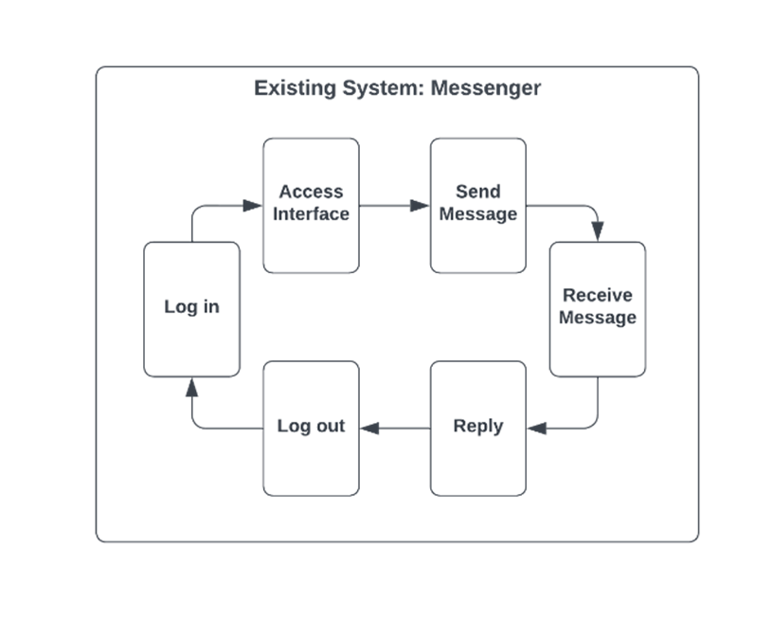Figure 1: Existing system (Messenger)

According to the survey, the existing system would be as simple as a messenger app, with many residents thinking that technology could only aid in communication. However, there are numerous aspects of village life that can be significantly improved through the Hillsview Homes portal. While the Messenger app is useful for real-time communication, group chats, official announcements, feedback, and social interaction, it has limitations such as dependency on internet connectivity, device compatibility issues, usability challenges, and security concerns. The Hillsview system offers a comprehensive solution, integrating services like online bill payments, community forums, a fixhub, event calendars, and service requests into a centralized platform. It enhances communication with real-time updates and encourages community engagement through forums and group chats.

Additionally, it ensures data security with robust measures and provides mobile-friendly access, making it a valuable tool for improving the overall quality of life and administrative efficiency within the community.

**REQUIREMENT DOCUMENTATION**

The proposed system for Hillsview Homes is a comprehensive portal designed to enhance various aspects of community living by integrating multiple critical features. These features include a user-friendly messenger application for real-time communication, online bill payments for utilities such as Meralco, Maynilad, PLDT, and Globe, and community forums to foster engagement and discussion among residents. The portal also provides a fixhub with verified service providers, event calendars to keep residents informed about upcoming activities, and a service request module for reporting maintenance issues and other concerns. Additionally, the system includes real-time news updates and community announcements, personalized user profiles, collaborative tools for organizing volunteer activities, and robust data security measures. Accessible through both web and mobile platforms, this portal is designed to streamline administrative processes, enhance convenience and security, and promote stronger community cohesion and well-being.

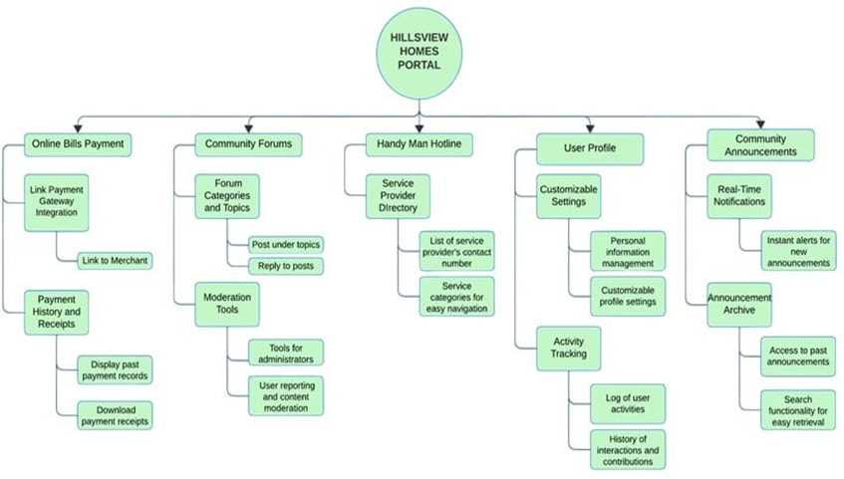Figure 2: Functional Decompostion Diagram of the proposed system

The Functional Decomposition Diagram (FDD) for the Hillsview Homes Portal breaks down the system into five main sections: Online Bills Payment, Community Forums, Handyman Hotline, User Profile, and Community Announcements. Each section contains specific features to help residents manage different aspects of their community life.

In the "Online Bills Payment" section, residents can pay their bills online and view their payment history, making the process convenient and streamlined. The "Community Forums" section provides a space for community discussions, where residents can browse various forum categories, create new topics, and view their own posts, fostering community engagement. The "Fixhub" section lists verified service providers along with their contact details and ratings, helping residents find reliable help for household needs. The "User Profile" section allows residents to customize their settings, Manage notifications, and track their activities, ensuring a personalized experience. Lastly, the "Community Announcements" section ensures residents receive important announcements and updates in real-time, keeping everyone informed about community matters

Figure 3: Use Case Diagram of the proposed system

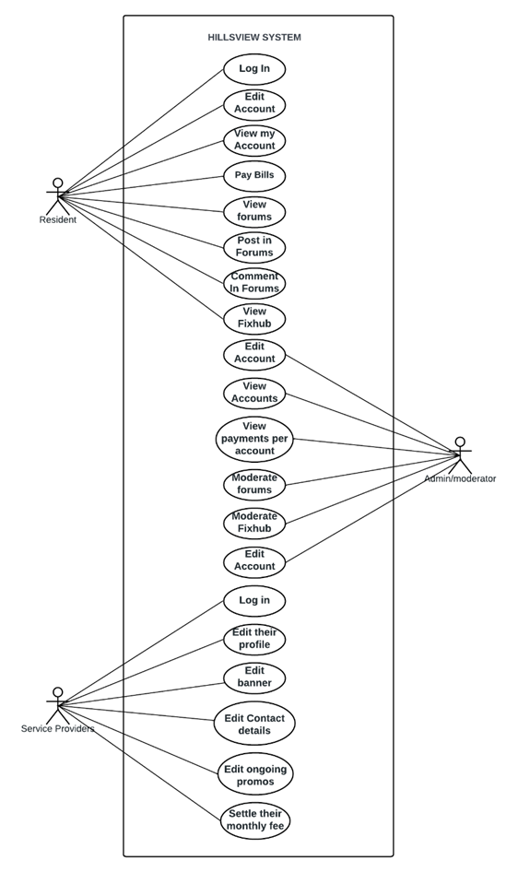

In the system, Residents and Admins have distinct roles with specific

interactions. Residents can log in to access and edit their accounts, view account details and billing history, pay bills, and engage with forums by viewing, posting, and commenting. They can also access the FixHub to manage service requests. Admins log in to manage their own account details, view detailed information about all resident accounts, review payment histories, and moderate forums and service provider information in the FixHub. This structure ensures that residents can efficiently manage their personal and billing information while engaging with the community, and admins can oversee and maintain the system's operations and community standards.

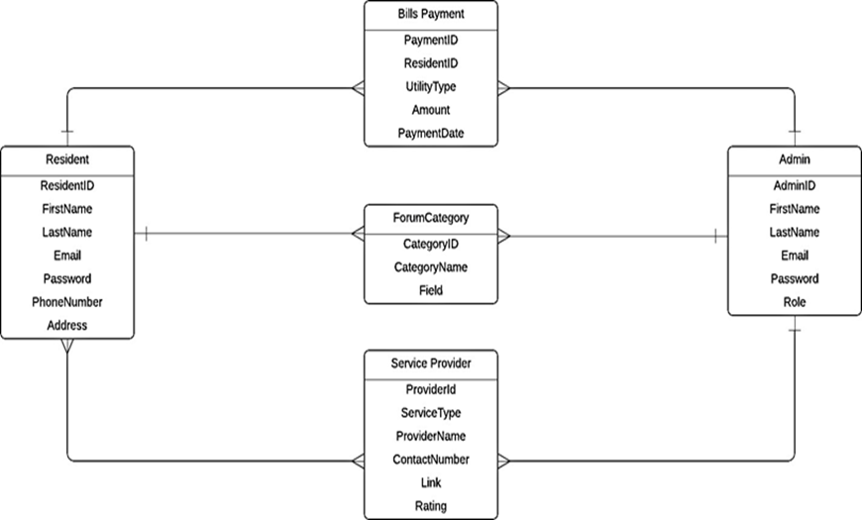Figure 4: Entity-Relationship Diagram of the proposed system

The Entity- Relationship Diagram (ERD) for the system includes five key

entities: Resident, Admin, Bill Payment, Forum Category, and Service Provider. Residents, identified by attributes like ResidentID and personal details, can make payments, participate in forums, and interact with service providers. Admins, defined by AdminID and role, manage the system, moderate forums, and oversee service interactions. Bill Payments track transactions made by residents, with attributes such as PaymentID and amount. Forum Categories organize discussion topics, each linked to multiple resident posts. Service Providers, identified by attributes like ProviderID and service details, offer services to residents. The relationships among these entities ensure a well-structured system where residents can manage accounts, pay bills, engage in forums, and access services, while admins maintain system integrity.

**DESIGN OF SOFTWARE, SYSTEMS, PRODUCT AND/OR PROCESS**

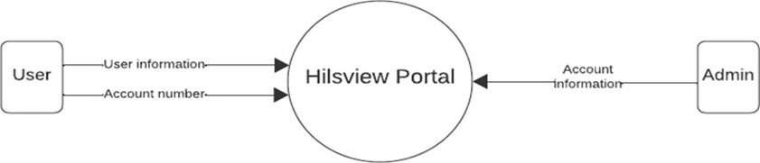Figure 5: DFD 0

Figure 5 represents the DFD Level 0, illustrating the entire system as a single

process. This diagram highlights the interactions between the system and external entities, specifically residents (users) and admins, and outlines the main data flows between these entities and the system.

* **Residents (Users):** Interact with the Hillsview Homes Portal to perform various activities such as paying bills, participating in forums, and submitting service requests. To access the portal, residents must log in using their user information. Additionally, if residents wish to use the online payments hub, they must input their account details, including bank or card information.
* **Admins:** Administer the portal, post community announcements, and manage service requests. Admins log in using their user information to access the system and perform their moderation duties.
* **Hillsview Homes Portal:** Serves as the central system that facilitates all interactions and processes for both residents and management.

Figure 6: DFD 1

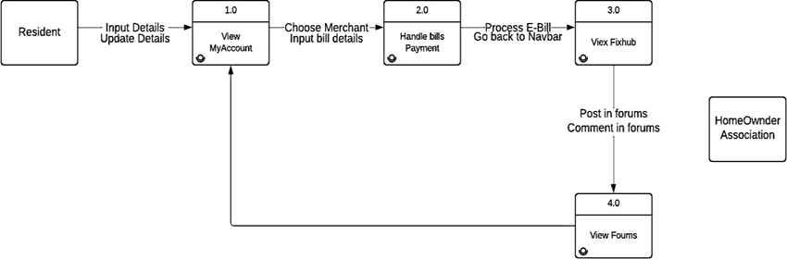

The Figure 6 Represents DFD level 1 , it provides a clear depiction of the major

functional areas of the Hillsview Homes portal, detailing the interactions between resident and admin processes. The distinct access restrictions between residents and administrators ensure that each user type has appropriate access to functionalities relevant to their role, maintaining security and efficiency within the portal. This structured approach allows for effective community management and enhances the overall user experience.

* **Resident Functions:** This process encompasses all the functionalities available to residents. It includes actions such as logging in, paying bills, viewing and creating posts in the community forums, and viewing service provider’s numbers.
* **Admin Functions:** This process covers all the tasks that administrators can perform. It includes actions such as editing and updating data, managing user accounts, posting announcements, and monitoring activities within the portal.

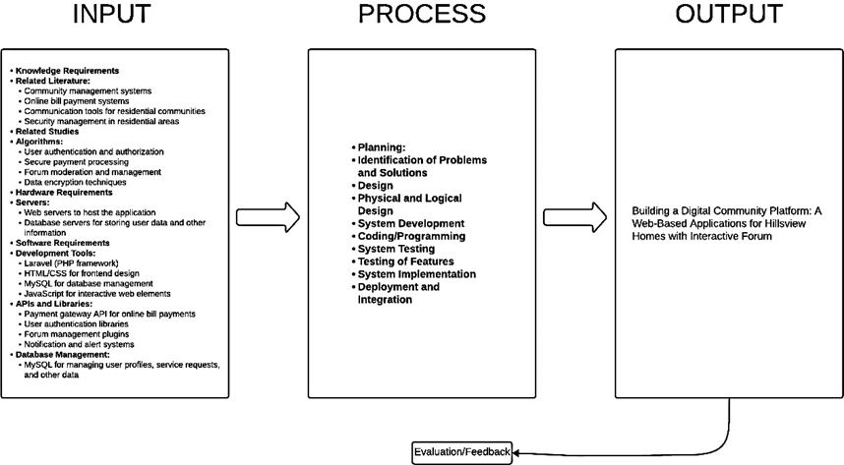Figure 7: Conceptual framework

The conceptual framework for the Hillsview Homes system is designed to create

a comprehensive digital platform that enhances communication, convenience, security, and data management for residents. This system integrates key features such as online bill payments, community forums, FixHub (fixhub), community announcements, and personalized user profiles. The development process follows the Software Development Life Cycle (SDLC) to ensure a systematic and structured approach, leading to a robust, efficient, and user-centered solution. The inputs for this framework consist of foundational knowledge, hardware, and software requirements necessary for design and development. Knowledge inputs include literature on community management systems, secure payment processing, communication tools, user authentication methods, forum moderation, and data encryption. The hardware requirements include web servers for hosting the application and database servers for storing user and community data. Software tools include Laravel for backend development, HTML, CSS, and JavaScript for frontend design, MySQL for database management, and various APIs and libraries for functionalities like payment gateway integration, user authentication, and notifications.

The development processes are grounded in the SDLC methodology, starting

with planning, where communication gaps, bill payment challenges, and service request inefficiencies are identified through surveys and discussions. Proposed solutions include a centralized communication platform, an online payment system, and an efficient service request tracker. In the analysis phase, user requirements are documented, existing workflows are assessed, and areas for improvement are identified.

During the design phase, the system’s architecture is planned to ensure seamless

interactions between its components. Wireframes and prototypes are created to visualize the user interface, while database schemas are designed to handle data related to user profiles, announcements, forums, and transactions Development involves coding the backend using Laravel, designing an intuitive frontend with HTML, CSS, and JavaScript, and integrating MySQL for database functionality. APIs are implemented for features like secure payments and notifications to enhance system usability.

The testing phase ensures the system's reliability through alpha and beta testing,

allowing the identification and resolution of bugs. Individual modules and the entire system are rigorously tested for functionality, usability, and security. In the implementation phase, the application is deployed on a live server, with phased rollouts to minimize disruptions and encourage user adoption. Administrators and users are trained to maximize the system's potential. The final phase, maintenance, involves continuous monitoring, updates based on user feedback, and maintaining the system’s security and efficiency.

The output of this conceptual framework is a well-designed, user-friendly, and

secure Laravel-based system that addresses the needs of Hillsview Homes. By following the SDLC, the platform ensures seamless communication, streamlined bill payments and service requests, improved security, and enhanced community engagement through forums and announcements, ultimately fostering stronger community connections and efficient management.

**DEVELOPMENT AND TESTING**

**Development Procedure**

The proponents we’ll be using is the Waterfall methodology for the

Hillsview Homes project due to its flexible and iterative approach. The Agile model allows us to continuously refine and adapt each phase of the project based on ongoing feedback and changing requirements. This is particularly advantageous for projects where requirements may evolve and where stakeholder collaboration is key to delivering a successful outcome.

Phases and Actions

Requirement Analysis is the initial phase where we gather and document all

system requirements. This involves conducting stakeholder meetings with residents and management to understand their needs and challenges, creating a detailed requirements document, and obtaining formal approval from all stakeholders to ensure alignment.

Following this, the System Design phase focuses on developing the system architecture and detailed specifications. We start with a high-level design outlining the system architecture, data models, and components. This is followed by creating detailed design documents that specify interfaces, data structures, and algorithms. These documents are reviewed and approved by stakeholders, including the PRO. Next, during the Implementation phase, we develop the system based on the design specifications.

This involves coding and developing the system in modular components,

ensuring each part is thoroughly tested before integration. Regular progress reviews with the PRO ensure development stays on track and meets expectations. The Integration and Testing phase involves combining all system modules into a cohesive whole and conducting comprehensive testing. System-wide testing helps identify and fix any issues or bugs, and user acceptance testing (UAT) engages residents to ensure the system meets their needs and expectations. Finally, in the Deployment phase, we prepare the live environment for system deployment, ensuring all necessary dependencies and configurations are in place. The system is then deployed with minimal disruption to residents, and training sessions are provided to both residents and management on how to use the new system.

**TESTING PROCEDURE**

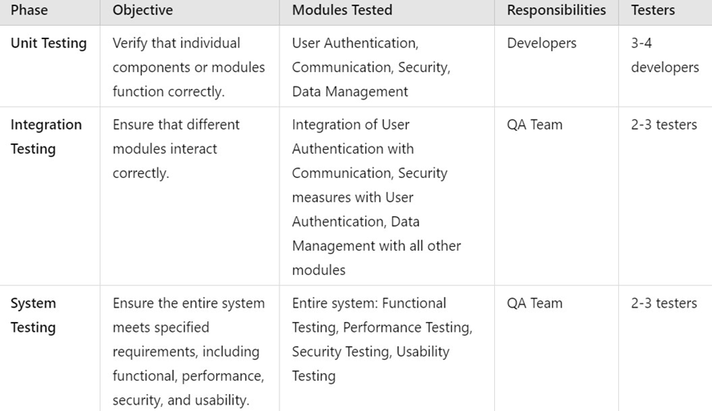Table 1: Testing Procedure Table

Testing Procedure table for the Hillsview Homes project, that is meticulously

organized into three distinct phases: Unit Testing, Integration Testing, and System Testing, each with clear objectives, responsibilities, and a specific number of testers involved. Unit Testing aims to verify that individual components or modules function correctly. This phase focuses on testing the User Authentication, Communication, Security, and Data Management modules. It is primarily the responsibility of developers, with a team of 3-4 developers ensuring each module works as intended before moving on to integration. Integration Testing ensures that the different modules interact correctly.

This phase tests the integration of the User Authentication module with the

Communication module, the integration of security measures with User Authentication, and the integration of Data Management with all other modules. The QA team, consisting of 2-3 testers, is responsible for this phase, focusing on the seamless interaction between components.

System Testing is the final phase, where the entire system is tested as a whole to

ensure it meets the specified requirements. This includes Functional Testing to verify all functionalities, Performance Testing to ensure the system handles the expected load, Security Testing to validate features like access controls and data encryption, and Usability Testing to ensure the system is user- friendly. The QA team, with 2-3 testers, is responsible for this comprehensive testing phase. This structured approach ensures thorough testing at each stage of development, resulting in a robust, secure, and user-friendly system for Hillsview Homes.

**IMPLEMENTATION PLAN**

The proposed system for Hillsview Homes is a Laravel-based digital platform

designed to enhance community living by addressing key challenges in communication, convenience, and security. The system will streamline information dissemination, provide advanced security measures, and improve data management for residents and management alike.

**Resources Needed:**

Hardware: Servers, workstations, networking equipment.

Software: Laravel framework, database management systems, security software.

Facilities: Training rooms, server rooms. Materials: User manuals, training materials.

Personnel: Project manager, developers, QA testers, trainers, IT support staff.

**Site-Specific Implementation Requirements:**

* Reliable internet connectivity.
* Secure server room with appropriate environmental controls.
* Access to current resident data for migration.

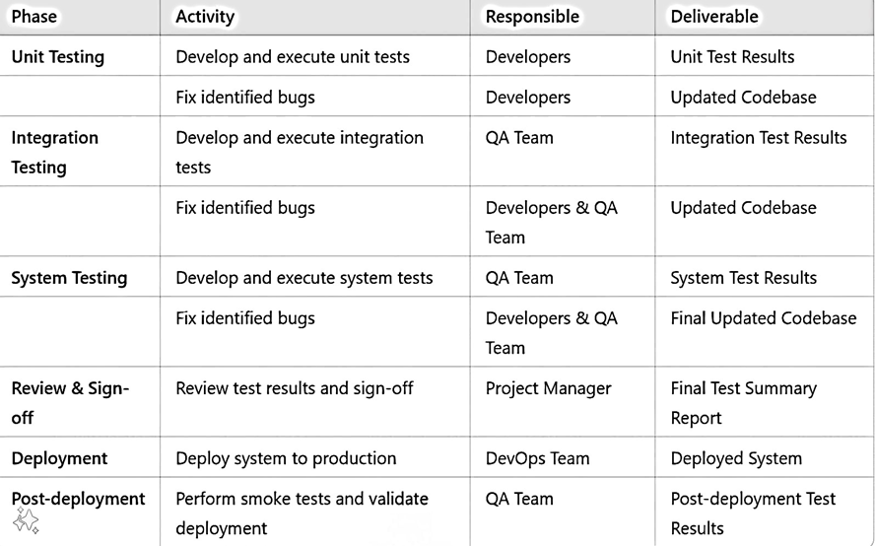Table 2: Implementation table

Table 2 is the Implementation Table plan for the Hillsview Homes project's

testing strategy. Organized into distinct phases, each with clear activities, responsibilities, and deliverables. During Unit Testing, developers are responsible for developing and executing unit tests to ensure individual components function correctly, with results documented and bugs fixed. Integration Testing follows, where the QA team develops and executes tests to ensure modules interact properly, with any bugs addressed collaboratively by developers and QA. System Testing involves the QA team creating and executing comprehensive tests covering functionality, performance, security, and usability, followed by bug fixes to ensure a robust system.

**CHAPTER 4**

**RESULT AND DISCUSSION**

**PROJECT DESCRIPTION**

The Hillsview Community Portal is a Laravel-based web application specifically

developed to address the communication, convenience, and security challenges faced by the Hillsview Homes community. This system provides various functionalities, including real-time communication tools, service management through the FixHub feature, secure data handling, and mechanisms for community safety. The portal has three primary user groups: residents, management, and service providers. Residents can use the system to access announcements, events, and real-time alerts while utilizing the FixHub feature to report and track household or community maintenance concerns. They also benefit from secure online payment capabilities for community fees or utility bills and personalized dashboards for viewing service histories and updates. For management, the system enables efficient administration of resident data and user roles, approval and monitoring of service requests, communication with residents for announcements and emergencies, and oversight of security incidents through real-time tracking and reporting tools. Service providers, on the other hand, can leverage the system for increased visibility within the community, manage appointments and service requests, and collaborate through exclusive offers tailored for Hillsview Homes residents.

The system was built using the Laravel framework, which follows the Model

View-Controller (MVC) architecture, ensuring a robust and scalable back-end infrastructure. The front-end design utilizes HTML, CSS, Bootstrap, JavaScript, and Vue.js, creating a user-friendly and responsive interface. Data management is implemented with MySQL, providing secure and reliable database functionality. The Hillsview Community Portal serves as a centralized solution designed to improve overall community living by fostering engagement and enhancing administrative operations. With its structured design, the system aligns with industry standards for reliability, usability, and scalability, addressing the evolving needs of a modern residential community.

**PROJECT STRUCTURE**

* **Resident Management Module**- The Resident Management Module provides a comprehensive interface for managing resident accounts and personal details. Admins are able to register and manage resident profiles, ensuring that all essential information (such as names, contact details, emergency contacts, etc.) is up to date. Residents themselves also have access to their profiles, allowing them to update personal information and track important details like service requests and billing history.

1. **Resident Registration and Login**: Residents can create accounts, reset passwords, and securely log into the platform.
2. **Profile Management:** Residents can update contact information, household details, and upload important documents (e.g., IDs, proof of residence).
3. **Account History:** Residents can view transaction records, service requests, and engagement history with the community or service providers.

* **Admin Management Module-** The Admin Management Module is used by Admins, to manage overall system operations. Admins can configure settings, approve or deny service requests, issue community notices, and monitor overall system health.

1. **User Roles and Permissions:** Admins can create and manage roles for different users (Residents, Service Providers, other Admins), defining their level of access to the platform.
2. **Resident and Service Provider Management:** Admins have the ability to edit and deactivate resident and service provider accounts when necessary.
3. **Reports and Analytics:** Admins have access to data dashboards that show metrics like active residents, ongoing service requests, outstanding payments, and general community activity trends.
4. **Security and Incident Management:** The Admin manages security reports and coordinates safety responses for the community. service requests, and update residents on the status of services.
5. **Service Provider Registration:** Local businesses and service providers register on the platform and list the services they offer (e.g., plumbing, electrical, cleaning, landscaping).
6. **Booking and Service Requests:** Residents can search and book specific services. Service providers can accept, decline, or schedule tasks based on availability.
7. **Service Completion and Feedback:** Once services are completed, residents can rate and review providers, and service providers can mark jobs as complete, with the system capturing detailed service records.

* **Communication and Notification Module-** This module enables real-time communication within the platform. It includes notices from the Admin to all Residents, as well as private messaging between Residents and Admins or Service Providers.

1. **Broadcast Messages:** The admin can send out messages that go to all registered users, ensuring residents are informed about important community updates, events, or emergency notices.
2. **Private Messaging:** Provides two-way communication between Residents and the Admin, or Residents and Service Providers for resolving inquiries or managing service requests.
3. **Push Notifications & Alerts:** This system sends out instant notifications for updates like service request status, new announcements, or important alerts (e.g., security threats, event reminders).
4. **Service Requests & Fix Hub Maintenance Module:** This Fix Hub system allows residents to report and track maintenance issues or service requests for things like plumbing, electrical work, or general repair needs in their homes.
5. **Request Creation and Tracking:** Residents can log their issues by selecting categories (e.g., plumbing, electrical, other repairs), and track the progress of each request.
6. **Prioritization and Scheduling:** Service requests are prioritized based on urgency (emergency, medium, low). Admins can assign jobs to service providers accordingly.
7. **Task Management:** Service providers are notified of new requests, can view tasks in progress, and mark tasks as completed. Feedback from residents on the quality of services completed is captured here.

* **Community Engagement and Events Module-** Fostering a strong sense of community is key, so this module facilitates organizing and managing social events, gatherings, or activities in Hillsview Homes.

1. **Event Creation and Management:** Admins can schedule events, create sign-up forms, and communicate details such as timing, location, and participation requirements.
2. **Resident Registration for Events:** Residents can view upcoming events, register to attend, and track their RSVP status.
3. **Event Feedback:** Post-event surveys and feedback features allow the admin to assess the success of community activities and adjust for future events.

* **Payments and Billing System Module-** Managing payments and handling community fees is streamlined through this system, reducing paperwork and manual processes for both Residents and Admins.

1. **Billing Information:** This module enables Residents to view bills and invoices for community fees, service payments, and other charges.
2. **Online Payments:** Integration with online payment gateways (e.g., credit cards, e-wallets) allows Residents to make secure payments directly through the system.
3. **Automated Reminders:** Automated reminders for due dates and overdue payments help Residents stay on top of their obligations.

**PROJECT CAPABILITIES AND LIMITATION**

***The following are the system’s capabilities:***

1. The system is compatible with multiple web browsers, including Chrome, Firefox, Edge, and Opera.
2. The system provides a dashboard that monitors the total number of registered residents, households, and service providers.
3. The system allows administrators to record and manage the profiles of residents and service providers, including personal, demographic, and transaction information.
4. The system can generate detailed statistics on active and inactive residents, categorized by gender, registration status, and other relevant metrics.
5. The system provides an overview of household compositions and tracks resident payment balances and financial obligations.
6. The platform features a service directory, enabling residents to view and access local businesses and service providers.
7. Residents can book appointments, request services, and monitor the status of their requests within the system.
8. Service providers can update their profiles, manage bookings, and promote services or special offers within the community.
9. The Fix Hub module allows residents to report maintenance concerns, track their status, and receive updates on their resolution.
10. The system enables administrators to share real-time announcements and updates, including community news, events, and emergency alerts.
11. Residents can view event details, RSVP to community activities, and receive timely notifications.
12. The system includes a secure payment module for residents to settle association fees, maintenance costs, and other financial transactions online.
13. The system offers robust security tools, allowing residents to report incidents, which are logged and tracked by administrators for resolution.
14. Administrators can generate analytical reports, including engagement statistics, financial summaries, and performance metrics for services.
15. The platform supports scalable operations, ensuring it meets the current and future needs of Hillsview Homes.
16. The user-friendly interface ensures accessibility for all users, minimizing technical barriers and enhancing ease of use.

***The following are the system’s limitations:***

1. The system is designed specifically for Hillsview Homes and may not be fully applicable or adaptable to other residential communities with distinct requirements.
2. The system’s capabilities are dependent on a stable internet connection for optimal functionality, which may pose challenges in areas with unreliable network coverage.
3. The current design focuses on addressing immediate needs and objectives, meaning additional features or advanced customizations requested by users may need further development phases.
4. User acceptance and engagement will play a critical role in the system's success, yet these factors are outside the scope of the project and may influence overall impact.
5. Although the system undergoes rigorous Alpha and Beta testing, unforeseen bugs or compatibility issues may arise upon deployment in live environments.
6. Financial transactions within the payment module are dependent on third- party gateways, limiting the system’s direct control over transaction processing times and potential delays.
7. The system assumes active participation from residents, service providers, and administrators for all functionalities to be effectively utilized.
8. Security features, while robust, may not fully mitigate risks of sophisticated cyberattacks or breaches outside the system's anticipated scope.
9. Resource constraints, including time and funding, have restricted the integration of features such as AI-based insights or enhanced predictive analytics.
10. The system does not provide dedicated applications for mobile platforms but relies on its browser-based responsive design for compatibility across devices
11. Training for administrators, service providers, and residents on system usage is outside the project’s scope and will require separate arrangements by Hillsview Homes.
12. Customization of generated reports may be limited to pre-defined formats and criteria available in the current system version.
13. System downtime for maintenance and updates might disrupt access temporarily and is unavoidable in ensuring system integrity.

Table 3: Testing Result (President)

Table 4: Testing Result (Vice President)

Table 5: Testing Result (Secretary)

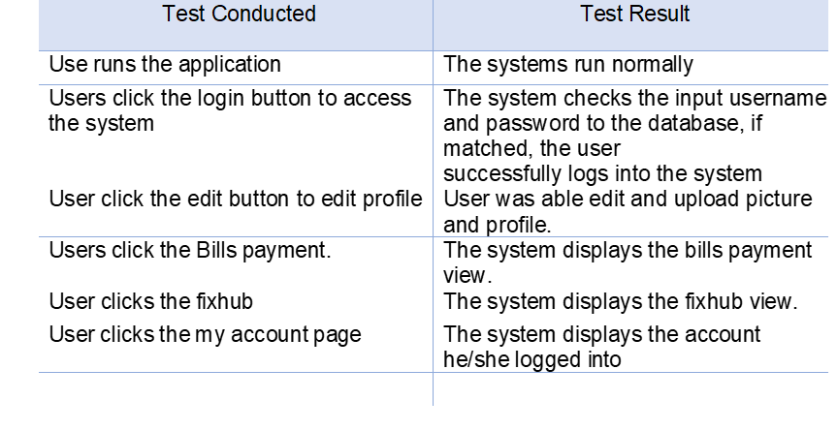Table 6 Testing Result (Admin)

**PROJECT EVALUATION**

The system’s performance was evaluated using the ISO/IEC 25010 software

evaluation form, which assesses various software quality attributes, including usability, compatibility, dependability, security, maintainability, portability, functional sustainability, and performance efficiency. The evaluation tool employs a numerical rating system, where five (5) represents the highest score, denoting excellent performance, and one (1) represents the lowest score, indicating poor performance.

The ratings are categorized into metrics: Excellent, Very Good, Good, Fair, and

Poor. The respondents for this evaluation included the president of the village, the vice president, the secretary, and an admin, offering a managerial and administrative perspective on the system’s usability and efficiency. The results provide an in-depth analysis of the system’s functionality and its ability to meet the community's needs. By incorporating both the feedback from key stakeholders and the performance metrics, the evaluation identifies areas where the system excels and aspects that require improvement.

Table 8 Evaluation Report from Actual Users



The table reflects the evaluation of the system by users who were given the

opportunity to grade it on a scale of 1 to 5, with 5 being the highest score, indicating the highest level of satisfaction. The results showcase the varying perceptions of users on the system’s performance across five key indicators.

**SYSTEM EVALUATION RESULTS**

The evaluation of the system, based on feedback from the village president, vice

president, secretary, and an admin, yielded the following results: Functionality received a mean score of 4, categorized as "Very Good." This indicates that the system fulfills its intended tasks effectively, meeting the expectations of its users and addressing the community's needs. Reliability scored a 2, rated as "Fair." This reflects that users identified inconsistencies in resolving errors or maintaining accurate and updated content, suggesting that improvements are needed in this area.

Usability achieved the highest score of 5, classified as "Excellent." This

demonstrates that the system is exceptionally user-friendly, making it intuitive and easy to navigate with minimal effort, even for non-technical users. Efficiency had a mean score of 3, categorized as "Good." This suggests that the system performs its functions satisfactorily, delivering expected results within acceptable timeframes, though there is room for optimization. Portability also scored a 2, rated as "Fair." This indicates that users encountered challenges in adapting or easily accessing the system, highlighting the need for greater flexibility and improved accessibility.

The overall mean score of 3.20, rated as "Good," suggests that while the system has notable strengths in usability and functionality, there are areas for improvement, particularly in reliability and portability. The evaluation emphasizes the importance of addressing these weaknesses to enhance the system's performance, usability, and user satisfaction.

**CHAPTER 5**

**CONCLUSION AND RECOMMENDATION**

**SUMMARY OF FINDINGS**

1. Functional Sustainability: The system successfully implements all required functionalities, leading respondents to give it an excellent rating for meeting its objectives.
2. Performance Efficiency: The system performs optimally, utilizing resources efficiently and maintaining high operational speed, which earned it an excellent rating from respondents.
3. Compatibility: As the system operates seamlessly across different platforms, it garnered an excellent rating for compatibility.
4. Usability: The user-friendly interface and intuitive design make the system easy to learn and navigate, resulting in excellent ratings for usability from respondents.
5. Reliability: The system maintains consistent performance even when issues arise, securing an excellent reliability rating.
6. Security: Strict access permissions ensure that only authorized individuals can access the system’s data, which earned it an excellent rating for security.
7. Maintainability: The system facilitates straightforward debugging and program analysis through clear design documentation, resulting in an excellent maintainability rating.
8. Portability: The system’s adaptability to diverse environments and its simple installation process contributed to it receiving an excellent portability rating.

**CONCLUSION**

Based on the issues addressed in the study's objectives and the findings from the system evaluation, the following conclusions were drawn:

1. Centralized Digital Platform: The Hillsview Homes Community Portal was successfully developed as a centralized digital solution to address the Hillsview community's communication, security, and service needs, as outlined in the project objectives.
2. Community and Personal Profile Management: The system enhances transparency and accessibility by enabling the management and viewing of personal and community profiles for residents, administrators, and service providers.
3. Streamlined Transactions: Essential features, including online bill payment, FixHub service requests, and real-time notifications, were implemented to simplify and optimize everyday transactions for residents.
4. Real-Time Monitoring and Communication: The portal effectively monitors service provider status, community announcements, and security updates while facilitating real-time interaction through integrated messaging tools.
5. Enhanced Security and Trust: By allowing residents and administrators to track security reports and activities, the system strengthens community safety and fosters trust among members.
6. Custom Reporting Capabilities: Administrators and service providers can generate detailed reports efficiently, promoting informed decision-making and optimizing community services.
7. Robust Data Security: The system ensures data security and privacy through protocols that restrict access to sensitive information, emphasizing safety and trust.
8. Compliance and Quality Assurance: The system was rigorously tested for compliance with ISO/IEC 25010 standards, receiving an "Excellent" rating in usability, compatibility, stability, security, maintainability, and portability.
9. User Adoption and Accessibility: A comprehensive user manual was developed to ensure ease of use and facilitate system adoption across the community.

**RECOMMENDATIONS**

Based on the findings and conclusions of this study, the following recommendations are proposed to further improve and expand the capabilities of the Hillsview Homes Community Portal:

1. Enhancement of Features: It is recommended to include additional modules such as scheduling or reminders for community-wide events and services to further improve resident engagement and convenience.
2. Integration with External Platforms: Consider integrating the system with local government or service provider platforms to streamline processes such as permits, utility bill management, and other administrative tasks, reducing redundancy and enhancing efficiency.
3. Deployment and Accessibility: It is suggested that the system be fully deployed and made accessible to all households within Hillsview. A phased deployment approach can be considered to ensure a smooth transition and address potential issues incrementally.
4. Testing and Feedback: Conduct further testing and pilot implementation across selected areas of the Hillsview community to identify potential issues or improvements needed. Regular feedback collection from residents, administrators, and service providers should guide future updates.
5. Training and Awareness Campaigns: Organize workshops and training sessions to familiarize residents and administrators with the system's functionality. Creating an onboarding manual or tutorial will help users fully utilize the system’s features.
6. Periodic Updates and Evaluation: Regular evaluations should be conducted to ensure the system remains efficient and relevant to the community’s needs. This includes upgrading the technology stack, addressing bugs, and adapting to any future changes within Hillsview Homes.
7. Scalability and Future Expansion: Investigate the system’s scalability to potentially serve other residential communities with similar needs while incorporating custom features unique to each community.
8. Data Analytics and Reporting Tools: Enhancing the system with robust data analytics and reporting tools will provide detailed insights into community engagement, system usage, and service satisfaction, enabling informed decision-making.
9. Security and Maintenance: Periodic security reviews should be conducted to maintain data integrity and protect user information. Continuous system maintenance will ensure smooth operation and long-term usability.

By adopting these recommendations, the Hillsview Homes Community Portal can continuously improve its impact on the community, fostering a connected, secure, and highly efficient residential ecosystem.

**REFERENCES:**

[1] K. E. Kendall and J. E. Kendall, Systems Analysis and Design: An Object- Oriented Approach with UML. Upper Saddle River, NJ, USA: Pearson, 2014.

[2] J. W. Satzinger, R. B. Jackson, and S. D. Burd, Systems Analysis and Design in a Changing World. Boston, MA, USA: Cengage Learning, 2015.

[3] R. S. Pressman, Software Engineering: A Practitioner's Approach. New York, NY, USA: McGraw-Hill, 2014.

[4] S. W. Ambler, "Introduction to UML 2 Sequence Diagrams," Agile Modeling, 2004.

[5] D. Rosenberg and K. Scott, Use Case Driven Object Modeling with UML: A Practical Approach. Boston, MA, USA: Addison-Wesley, 2001.

[6] A. Adesipo, "Smart Community Security and Privacy: A Sensor-Based Approach," Sensors, vol. 20, no. 4, pp. 1-20, 2020.

[7] S. Kim, "Smart City Implementation: A Case Study of Seoul," Urban Studies, vol. 53, no. 5, pp. 1-20, 2016.

[8] K. Polyzois, "Enhancing Indigenous Community Participation in Community Planning Through Online Tools," Journal of Community Informatics, vol. 14, no. 1, pp. 1-20, 2018.

[9] R. J. Moore and M. Carter, "Designing Engaging Digital Communities: A Framework for Managed Community Experiences."

[10] M. Conti, J. Li, and S. Ahmed, "Security and Privacy in Smart Communities: Challenges and Opportunities."

[11] S. J. Lee and T. M. Hale, "Building a Smart Community Through the Integration of Technology, Social Capital, and Collective Efficacy."

[12] M. A. Badamas and H. M. Hasan, "The Role of Digital Technologies in Enhancing Community Engagement and Participation."

[13] J. Pluto-Kossakowska, "Use of Dashboards in City Planning: A Review of Current Practices and Future Directions," Sustainability, vol. 14, no. 17, 2022.

[14] M. I. Khan, M. Waqas, and G. Muhiuddin, "A Comprehensive Review of Online Bill Payment Systems: Models, Technologies, and Trends."

[15] Y.-t. Lee, W.-h. Hsiao, C.-m. Huang, and S.-c. T. Chou, "An Integrated Cloud-Based Smart Home Management System with Community Hierarchy," IEEE Transactions on Consumer Electronics, vol. 62, no. 1, pp. 1-9, Feb. 2016.

**APPENDICES**

1. Relevant Source Code

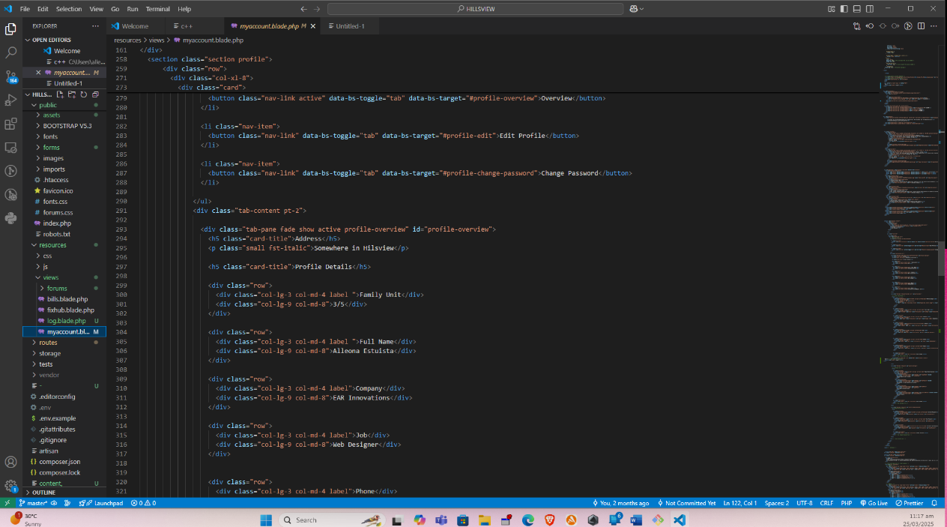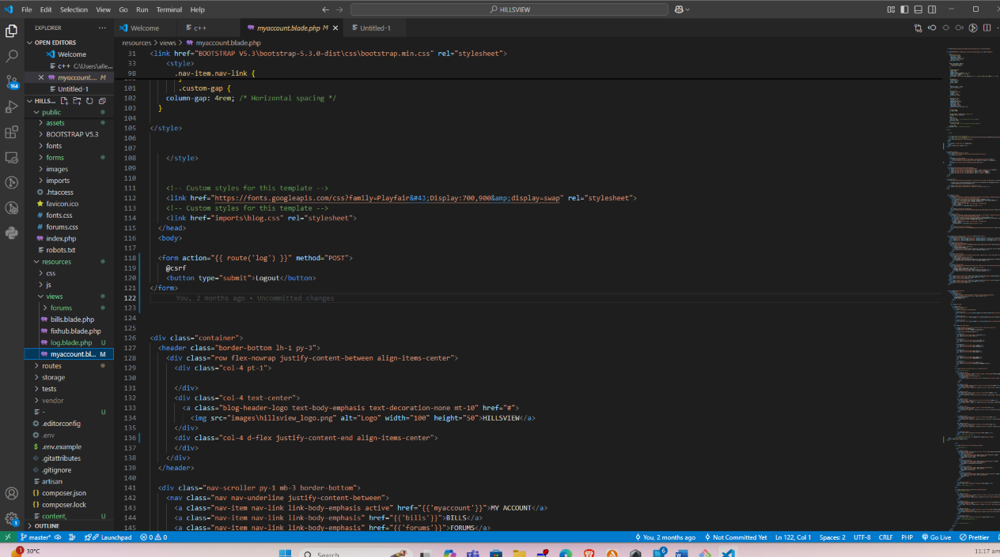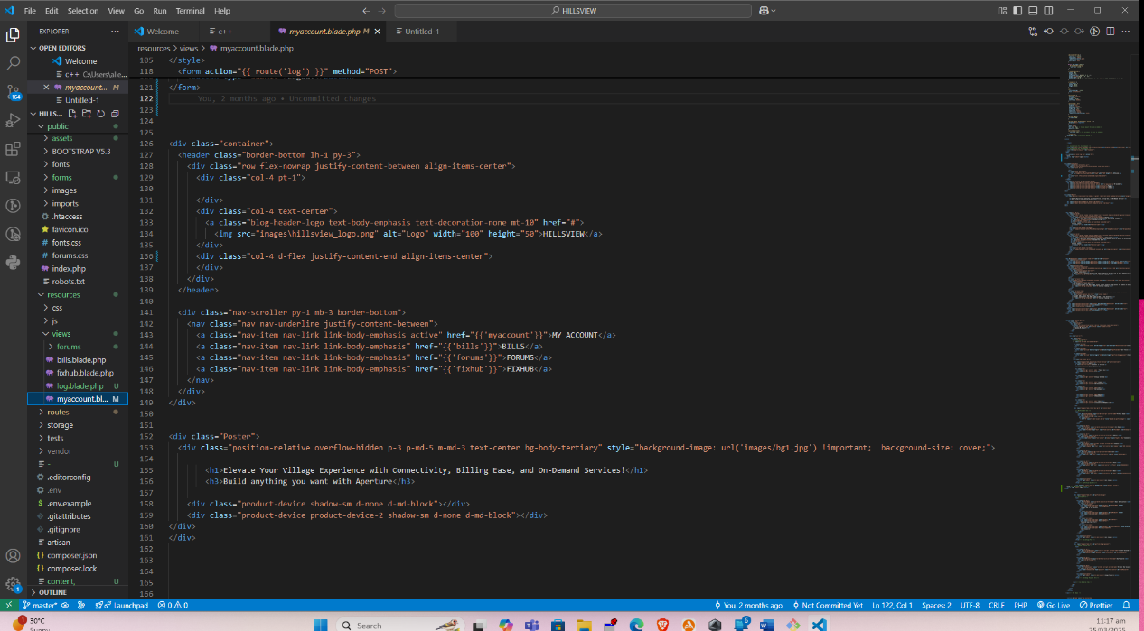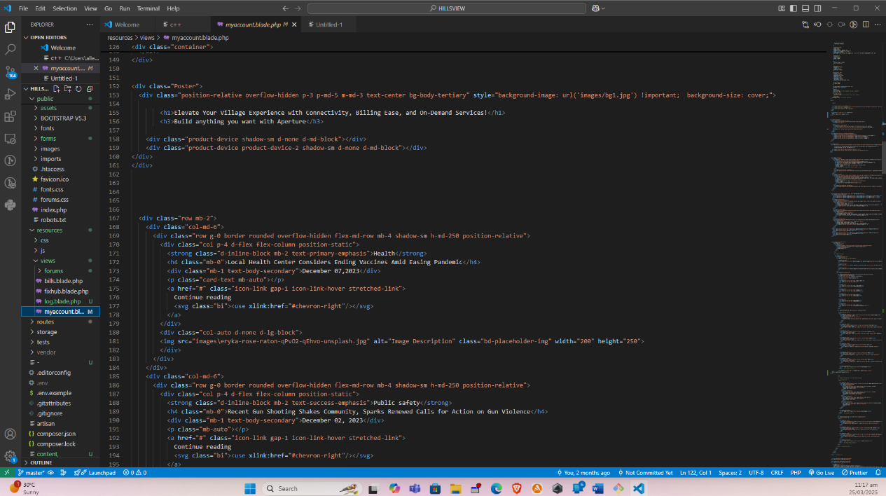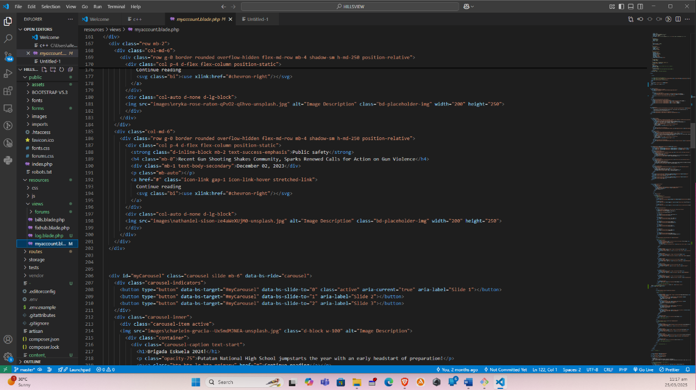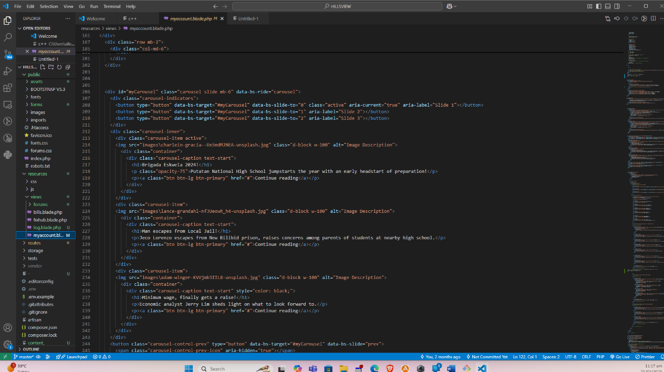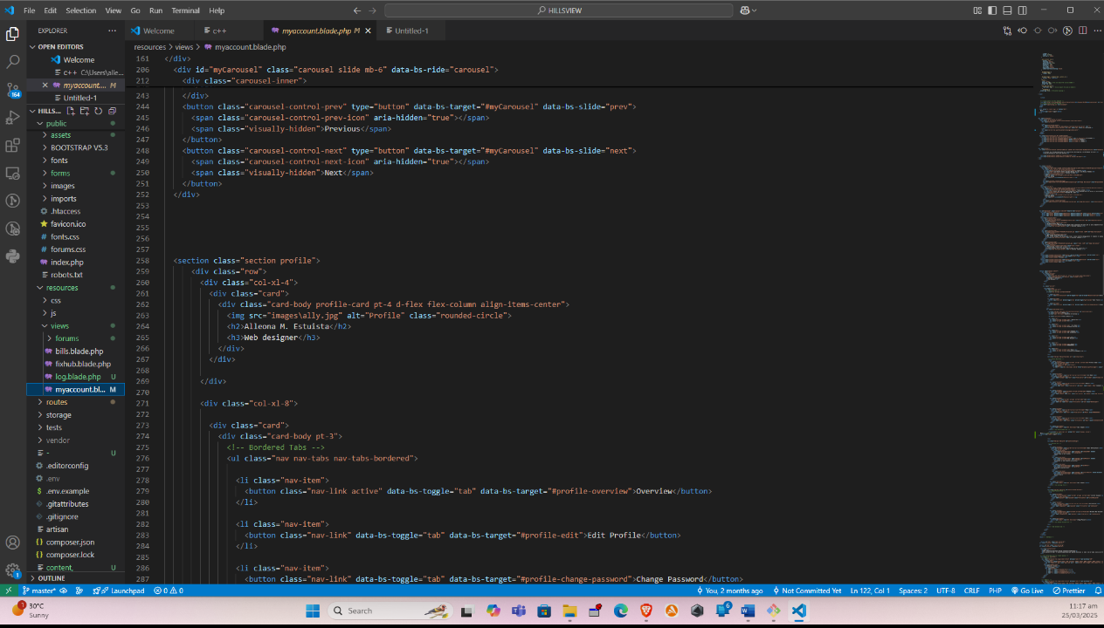

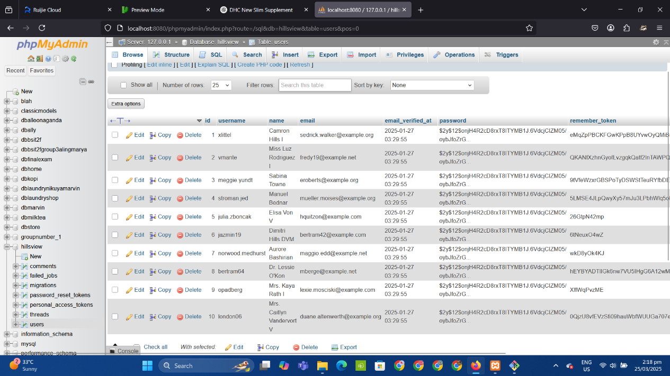

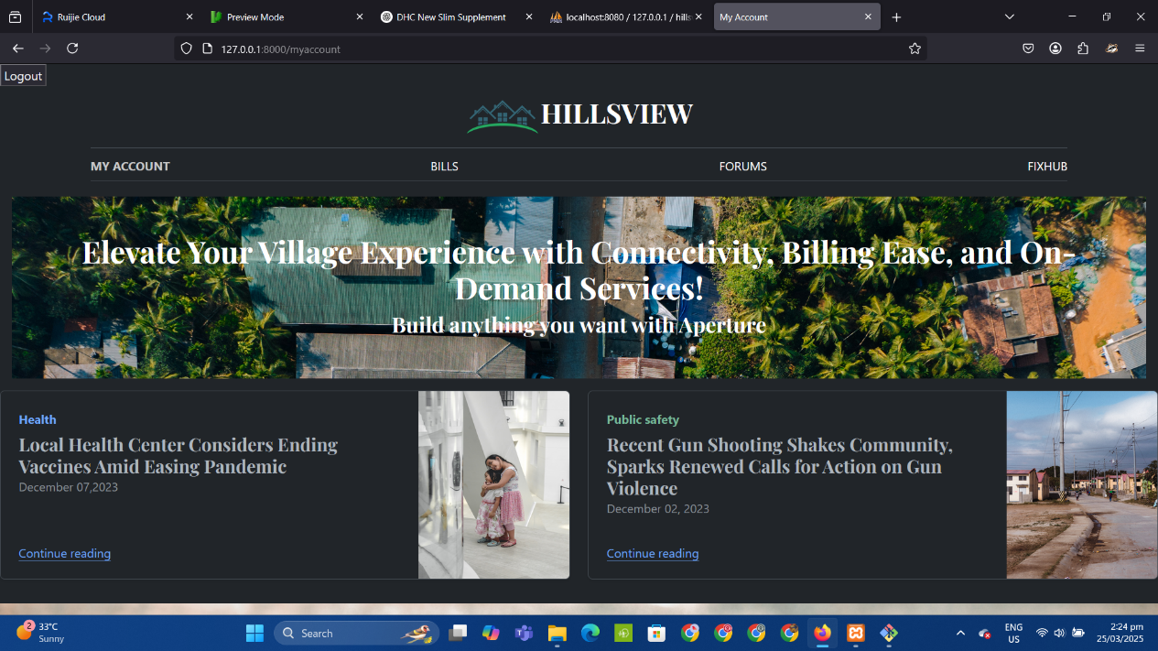

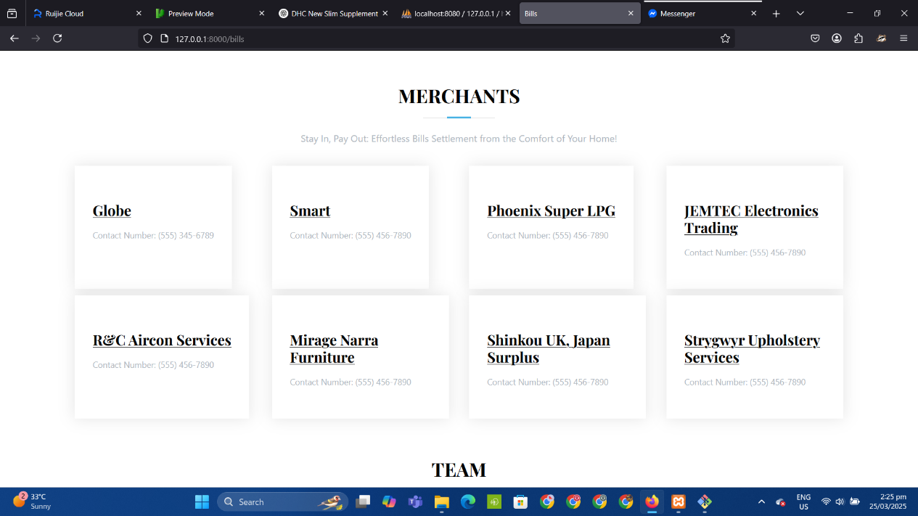

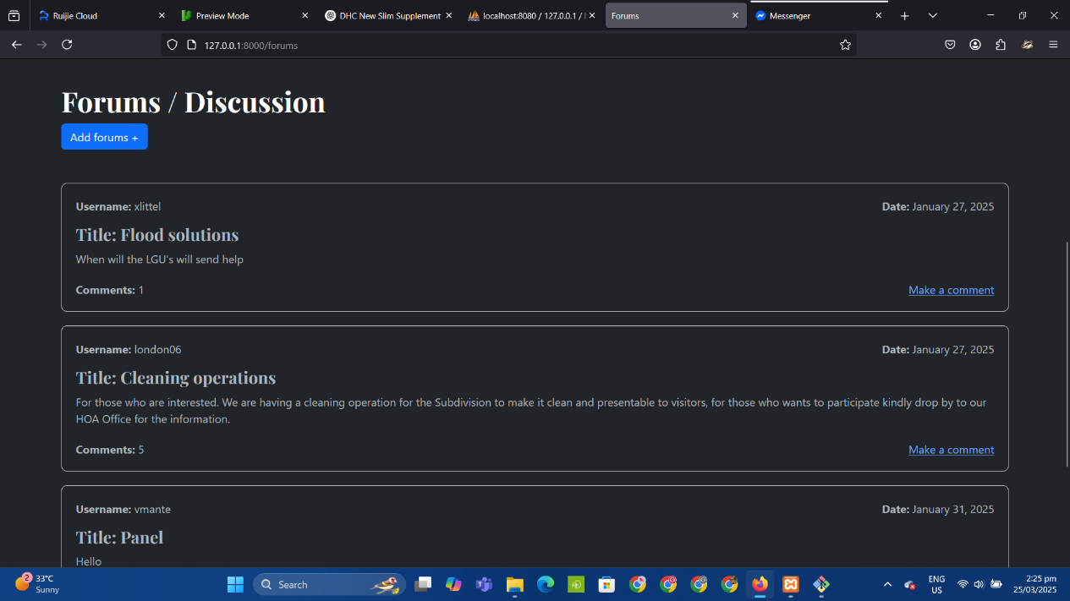

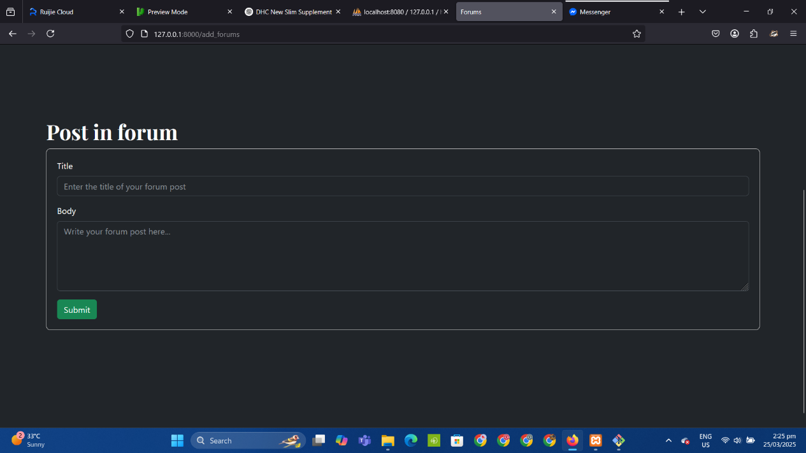

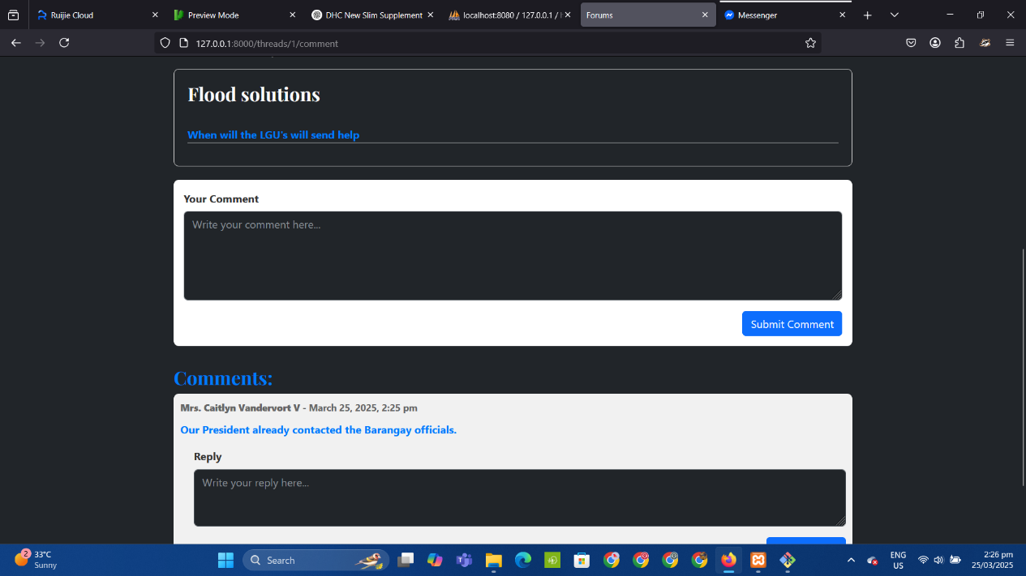

1. Evaluation Tool Sample







1. Sample Input/Output/Reports

**CONSENT LETTER**

Alleona, Estuista

Bacoor, Cavite, 4102

alleonaestuista03@gmail.com

February 18, 2024

Mr. Joey (P.R.O)

HOA Homeowners

Blk 1 Lot 8 Hillsview Homes, Putatan Muntinlupa City, 1772

Dear Mr. Joey,

Subject: Confirmation of Follow-up Interview and Essential Residents' Survey with Waiver

I am pleased to inform you that we are organizing a follow-up interview to gather feedback on the implemented system. Additionally, we are seeking your permission to conduct a survey among the residents. It is imperative to emphasize that our approach to the survey will prioritize respect for the residents' autonomy and consent. Before posing any questions, we will present them with a waiver to sign, granting us permission to conduct the survey.

Your support in this matter would be immensely valuable in ensuring the participation and cooperation of the residents, thereby enhancing the quality and relevance of our research findings. We kindly request your confirmation for both the follow-up interview and the residents' survey with the waiver by signing below:

Ancajas, Joey

Hillsview HOA (P.R.O)

Respectfully yours,

Ancajas, John Andrei

Estuista, Alleona

Rili, Marvin

Researchers

1. User’s Guide
2. Request Letters
   * Adviser
   * Defense Panel
   * Language Editor
   * Endorsement for Title Presentation
   * Endorsement for Oral Presentation
   * Endorsement for Book Compilation
3. Pictures showcasing the data gathering, investigation done
4. Curriculum Vitae